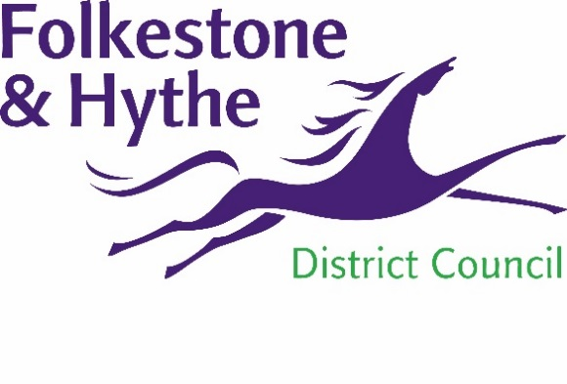
NEWS RELEASE

05 January 2021

FOLCA AND CIVIC CENTRE TO BE USED FOR VACCINATIONS
Both Folca (the former Debenhams building) and the Civic Centre in Folkestone are due to be used as vaccination centres against COVID.
The two Folkestone & Hythe District Council owned buildings are going to be part of the massive immunisation rollout of the COVID vaccine when they become operational as vaccination hubs in a few weeks. Residents will be invited to get the vaccine when it is their turn and advised which hub they should attend to get their jab.
Folkestone & Hythe District Council proposed the use of Folca before Christmas and officers have been working hard on plans and practicalities with the NHS East Kent Clinical Commissioning Group ever since.
Cllr David Monk, Leader of Folkestone & Hythe District Council, said: “We are delighted to be able to provide the use of our buildings and particularly Folca to be part of such a momentous rollout.”
The plan for Folca has always been that we want it to benefit the town and the wider community. What better way for it to be used in the interim that as vaccination hub playing a pivotal role in making our community safer.”
XXXXXXX, XXXXX at NHS East Kent Clinical Commissioning Group, said: “XXXXXXXXXXXXXXXXXXXXXXXXXXXXXXXXXXXXXXXXXXXXXXXXXXXXXX”
Both Folca and the Civic Centre buildings can be easily accessed from Folkestone bus station and Folkestone Central railway station.
For more information about the other sites due to be used for vaccinations visit https://www.kentandmedwayccg.nhs.uk/covid19vaccine

Notes to Editors:
For more information, please email communications@folkestone-hythe.gov.uk

Follow us on Facebook: @FolkestoneandHytheDC
Follow us on Twitter: @fstonehythedc
Follow us on Instagram: @folkestonehythedc
Follow us on LinkedIn: Folkestone & Hythe District Council

